1. Text

   Description automatically generated
2. What is a test in an API?
   1. This is a question that many people learning API testing have on their mind.
   2. Our initial focus with testing is to ensure that the API performs as expected and returns the correct responses for a given request.  
      This form of testing is called functional testing as we’re testing the functionality of the API.   
      Shape, polygon

      Description automatically generated
   3. Of course, to be able to do so, we need to work with the **API Documentation** and understand the **business processes of the API**.  
      Just because an endpoint returns status code 404, doesn’t mean that the API doesn’t work.  
      Diagram

      Description automatically generated with low confidence
3. When testing an API, at minimum we should verify the status code of every endpoint.
4. 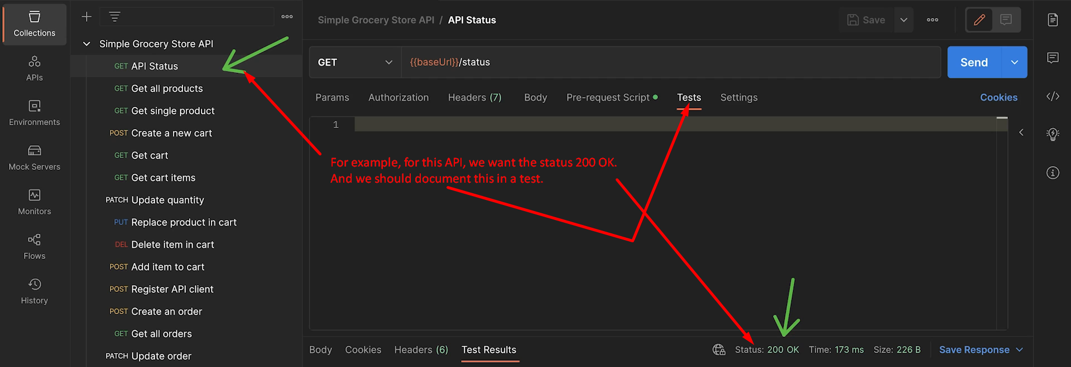
5. 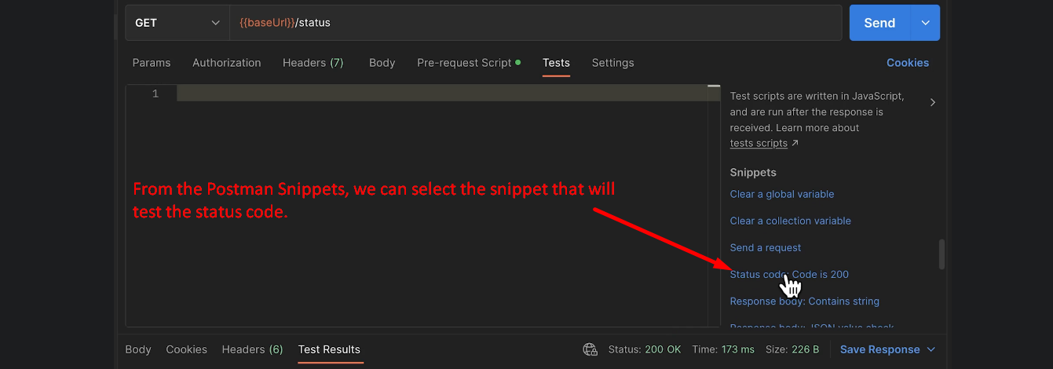
6. Graphical user interface, text, application

   Description automatically generated  
   If due to some reason, the endpoint starts working differently or maybe endpoint doesn’t exist or something else happened with this endpoint, the fact that here we have a test that is a documentation.  
   It is telling us look when we have tested this API manually and when we have written test the status code was 200.